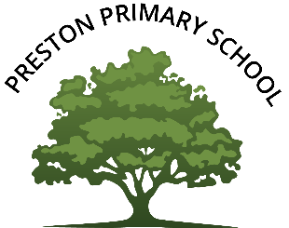

Preston Primary School

Declaration of Interest 2023 / 2024

